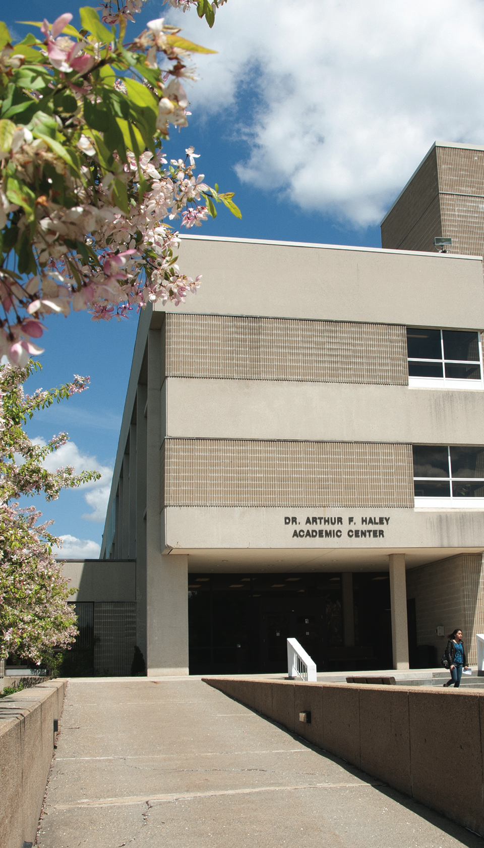
Pool Rules
(Please review these with your children)

- NO running on the pool deck.
- All swimmers must take a cleansing shower before entering the pool area.
- NO street shoes on the pool deck! Please remove them before entering the pool area.
- Please do not chew gum on the pool deck or while swimming
- NO food or drink allowed on the pool deck.
- Absolutely no glass containers allowed at any time.
- Swimmers who are not toilet trained must wear both a swim diaper and a covering suit

Swim Lesson Handbook

Fitness and Wellness Center
444 Green St, Gardner MA.
978-630-9212
Class Times
Please be on time for your lesson. This will ensure that your child is getting the full attention of the instructor a s well as participating fully in all skills for the day. We recommend arriving at least 5-10 minutes early in order to make sure your child is changed, showered and ready to begin class at the designated time. If you do arrive late to class, please sit your child on the edge of the pool at the shallow end and wait with them until the instructor is ready to bring your
swimmer into class.

Class Schedule
Please see the current class schedule for dates, days and times of class offerings. It is your responsibility to make sure you are able to attend all classes and to be aware of days when there is no class due to holidays or events at the pool.
978-630-9212 mwcc.edu/fitness
AA/EEO Institution
Swimwear
All swimmers who are not toilet trained are required to wear swim diapers plus a covering bathing suit. NO REGULAR DIAPERS ARE ALLOWED IN THE POOL AT ANY TIME.
The water temperature is generally between 82 and 84 degrees. Smaller children may wear covering, non-cotton layer over their swim suits if desired.
mwcc.edu/fitness
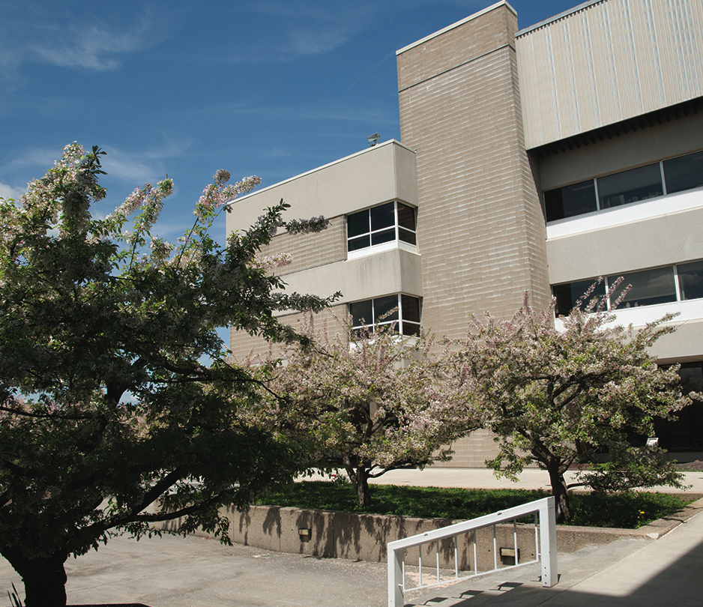
Class Format
At the beginning of class, please bring your child to the shallow end of the pool and have them sit on the edge. Remain with them until the instructor has taken attendance and/or is ready to begin class. During class, please remain seated on the benches located in front
of the glass wall. Please only approach class at the request of the instructor. This will enable your child to remain focused on the instructor
knowing you are in the same area and not wandering around looking for your presence/ whereabouts.
All swimmers must have an adult on the pool deck at all times while they are participating in class. Once class is over, students will only
be let go from class when a parent/guardian is present.
Welcome to the Mount

We are pleased to offer American Red Cross Swim Lessons at the Mount! The American Red Cross program offers 2 separate age groups to choose from.
Preschool Aquatics is appropriate for children ages 5 and younger. In this program there is a Parent/Child class as well as 3 levels of swimming, Pre1, Pre2 and Pre3.
The Learn-To-Swim program is appropriate for children ages 6 and above. The Red Cross offers 6 levels of swimming abilities, Levels 1 – 6. Cancellations/ Credits/ Refunds
The Mount reserves the right to make
schedule changes to better serve our
members or to cancel/combine instructional classes and programs due to insufficient enrollment.
Please make sure your calendar will allow you to enjoy all of the lessons/classes before enrolling in a program. If the Mount must cancel a class due to the following:
1. Mechanical issues
2. Fire evacuation
A make-up class will be scheduled to coincide with the pool and instructors schedules. If the student is unable to attend this make up, a credit for the missed class will be placed on the students account.
No credits or makeups will be issued for
circumstances which are beyond the control of the Mount including:
1. Missed classes due to illness or vacation or
if you should choose not to attend.
2. Inclement weather
3. Power outages
4. No water supply
Refunds are only awarded in extreme
circumstances. All requests for refunds must be submitted in writing to the aquatics
director. No refunds or credits will be issued week prior to the first date of class.
David C. Graham
Aquatics Director
Fitness and Wellness Center
Mount Wachusett Community College
978 – 630 – 9354
d_graham@mwcc.mass.edu

Thank you for choosing the Mount for your child’s swim lessons! Please review the following information regarding swim lessons at the Mount. We encourage you to review this information as it designed to help both parent and child have an enjoyable experience while participating in the swim lesson program. If at any time you like to speak to me directly, please feel free to stop in and see me or contact me via any of the means below. I look forward to seeing you at the pool!

