Office of Academic Affairs
ACADEMIC DEPARTMENT REVIEW TEMPLATE
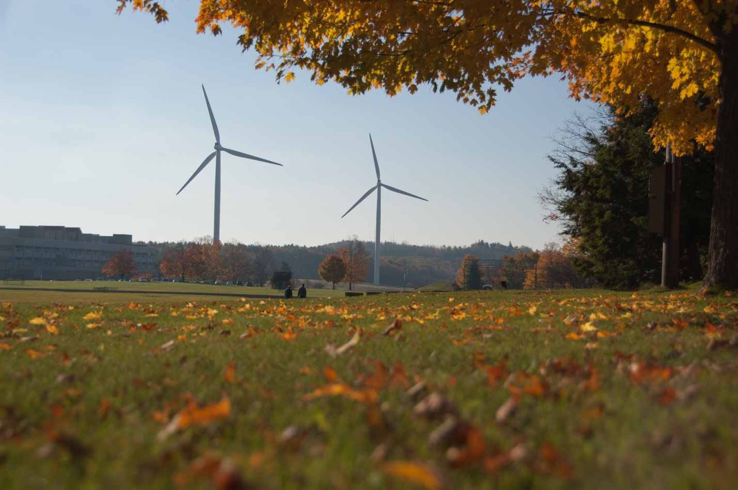
DEPARTMENT DEPARTMENT TEMPLATE

SECTION I: ACCREDITATION/ APPROVAL/ CERTIFICATION

Components

The Department Review Components are divided into five discrete, but interrelated components.

- Section I: Data

- Section II: Mission, Goals and Target Population

- Section III: Curriculum

- Section IV: Instructional Support

- Section V: Additional Questions and Department Evaluation Summary

Section I: Data

This section will be completed by the Division Dean and the Department will provide an analysis of the data.

- Describe the course enrollment data for the past five years. Please list each course in the department and its enrollment for the past five years. Answer the questions below.
- If enrollment numbers decreased, please offer an explanation and provide a plan for improvement.
- If department enrollment has increased, please describe any needs to support the continued growth. Additionally, can the labor market bear further enrollment increases?
- What is the enrollment goal for the next year?
- What is the enrollment goal for the next five years?

- What is the completion rate for each course? What percentage of students fail?

- What courses, if any, do students have a difficult time completing? What can be done to improve course completion rates? Please describe a plan for improving the completion rates.

6. Do these courses transfer to other institutions? Please provide a list of each course that transfers and where they transfer to and which course they transfer in as.

Section II: Mission, Goals, and Target Population
Department faculty, staff and, where appropriate, students provide information for this section.

1. What is the mission statement of the department? What is the department purpose?

Section III: Curriculum – Department Outcomes

- Please complete Table 1. Indicate the following:

- Department Outcomes: What student will know and be able to (must be specific and measurable) demonstrate. Five to ten major department outcomes should be listed. If there is nothing currently in place that is intended to provide for attainment of a particular outcome or to assess the extent to which the outcome has been realized. Please leave the appropriate space blank. The “blanks” will help to identify areas that need further development – for example, what activities/assignments will enable the student to achieve the specified learning outcomes? (If the strategy is contained within a particular course, please list the course first, with the relevant activity or activities listed next to each course.)
- Identified Courses: List of courses where department outcomes are addressed and data is collected.
- Provide examples for each course per each department outcome and provide the teaching method, provide the
assessment method and the assessment results.

Table 1: Student Outcomes and Teaching and Learning Assessment Inventory:

Department Outcomes | Identified Courses (where the department objectives were taught)

Table 2: Actual Course: Teaching Methods, Assessment Methods, and Assessment Results

Instructions: List each course per each department objective and provide teaching method; for the same course, provide the assessment method.

Department Objectives | Course (where the department objectives were taught) | Assignments  (to measure learning objectives of the department objectives) | Assessment Method of the Learning Objective

In the space below provide examples of how the outcomes results were used to initiate change in the department:

- Using the chart below, please indicate the courses in your department that satisfy the Institutional Student Learning Outcomes. List strategies for attaining each competency (i.e. through specific activities or projects) and describe how the learning of each will be assessed.

Institutional Student Learning Outcomes

Competency | List Each Course within the Department that addresses the outcomes
1. ANALYZE information to formulate ideas and to solve problems
2. COMMUNICATE information, ideas and opinions effectively for a range of purposes and audiences
3. CREATE original work that demonstrates knowledge of their field
4.ENGAGE within local, national, and global communities
- RESEARCH ideas and examine them using current knowledge

Instructions: Pick one course per each department outcome and provide teaching method; for the same course, provide the assessment method and the assessment results.

Department  Objectives | Course (where the department objectives were taught) | Assignments (to measure learning objectives of the department objective) | Assessment Method

In the space below provide examples of how the outcomes results were used to initiate change in the department:

3B. Create (update) a Curriculum Map (attachment). Please indicate on your curriculum map where both department level and institutional level general education core competencies are 1 = introduced; R = reinforced; E = emphasized.

3C. How do you measure student learning upon completion of the department? Describe the process and give examples of results for the past five years.

4. Please describe the work-based learning opportunities with the department (i.e., co-op, internships, service learning, civic engagement). What percent of department students participate in each of these activities? Indicate any challenges and identify opportunities with incorporating work-based learning.

6. Are students prepared for their department courses? What courses do you feel students need more preparation and why? Be specific, when indicating skill deficits.

7. What are the current pedagogical approach to teaching your department courses? Please provide an example at the entry level, middle level and capstone levels.

8. Describe any plans to introduce new content or delivery methods into required or elective courses.

Section IV: Instructional Support

- What library resources does your department rely upon? Are your needs being met? What resources would you like the library to obtain?

- Using course enrollment data, please discuss the adequacy of the
staffing level to teach and advise for students enrolled in the department.

- What are you doing to provide academic advising to your new and continuing students?

- What can you do to strengthen academic advising for students in your department?

- How many adjuncts teach department courses? Please list all adjuncts and their degree qualifications. How are course objectives and assessment data communicated with the adjuncts? If there is no mechanism in place, please indicate how this information will be communicated with faculty.

- Using the table below, please comment on the availability and adequacy of these support services for students. (i.e. tutoring, media, library, disability services, computer labs etc.) Be specific about any current deficiencies or projected needs:

Support Service: | Availability: | Adequacy: | Deficiencies: | Projected Needs:
Computer Labs
Disability Services
Library
Media
Tutoring
Other

5. How adequate and appropriate are department facilities and equipment? Please be specific about current deficiencies or projected needs.

- Are you satisfied with the course scheduling process? Are there any changes you would like to see happen?

- Are there unmet professional development needs of department faculty or staff? If so, please describe.

- If the department is offered at an instructional site or online, please describe enrollments in courses supporting the department. Are students able to get the courses that they need?

Department Evaluation Summary

This section should be completed based upon review and consideration of both the data supplied in Section I and the questions posed in Sections II, III, and IV.

A. Major Department Strengths

B. Department Weaknesses or Needs for Improvement

C. Plans for improving or correcting identified weaknesses
(Please include proposed time lines where that is possible).

APPENDIX 1

ENROLLMENT DATA

APPENDIX 2

RETENTION DATA

APPENDIX 3

OUTCOMES ASSESSMENT PLAN

APPENDIX 4

OCCUPATION PROFILE REPORT

APPENDIX 5

ADVISIORY BOARD MINUTES

APPENDIX 6

SAMPLE PROGRAM COURSE SYLLABI

