Office of Academic Affairs
ACADEMIC PROGRAM REVIEW TEMPLATE
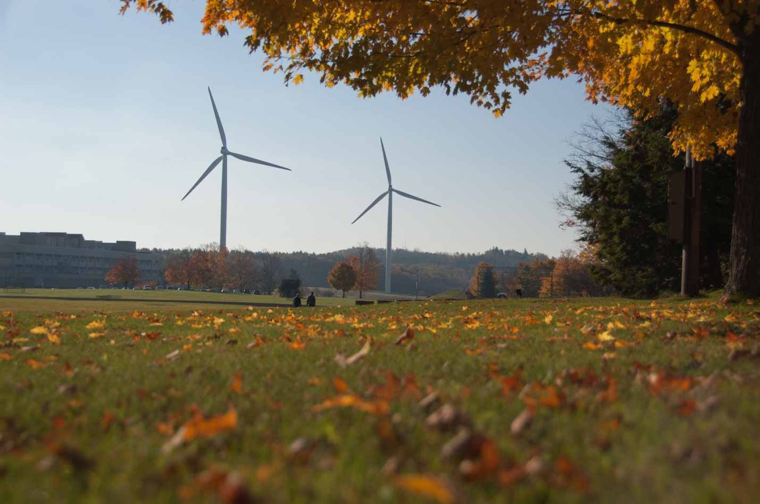
PROGRAM REVIEW TEMPLATE

SECTION I: ACCREDITATION/ APPROVAL/ CERTIFICATION

A. Does the program have external (specialized) programmatic accreditation?

Yes _____ No ____

IF NO, skip to I (B).

IF YES, please complete items 1 through 8 below.

1. What is the name of the programmatic accreditation agency?

2. What is the current accreditation status of the program?

3. What date was the last accreditation status awarded?

4. What is the anticipated date of the next accreditation action?

5. How often does the program file an official report with the
accrediting agency?

6. Where is the program currently in the review schedule (e.g., year 3 of a 7-year cycle)?

7. What were the strengths and weaknesses of the program,
as identified by the accreditation agency during the last accreditation activity? (Base your response in this area to the citation of Standards.)

8. How has the program been revised to address the citations or recommendations?

9. Please attach this page to a copy of your accreditation report.

10. Please answer any questions in the program review that have not been addressed in the accreditation report.

Components

The Program Review Components are divided into five discrete, but interrelated components.

- Section I: Data

- Section II: Mission, Goals and Target Population

- Section III: Curriculum

- Section IV: Instructional Support

- Section V: Additional Questions and Program Evaluation Summary

Section I: Data

This section will be completed by the Division Dean and the Department will provide an analysis of the data.

- Describe the program’s enrollment data for the past five years.
- If enrollment numbers decreased, please offer an explanation and provide a plan for improvement.
- If program enrollment has increased, please describe any needs to support the continued growth. Additionally, can the labor market bear further enrollment increases?
- What is the enrollment goal for the next year?
- What is the enrollment goal for the next five years?

- What is the Fall to Spring and Spring to Fall and Fall to Fall persistence data for the most recent academic year.
- How does this compare to the college persistence rates?
- Are persistence rates above 75%?
- If not, why do you believe the number is lower? Please describe any improvement plans in place.

- What courses, if any, do students have a difficult time completing? What can be done to improve course completion rates? Please describe a plan for improving the completion rates.

- What is the graduation rate for the past 5 years? How has it changed? Why?

- During a five year period, what is the average percentage of students who transfer? During the same time frame, what is the average percentage of students who find employment? Have the transfer and employment percentages remained consistent? If not, explain why you think they have changed.

6. Please summarize findings from student surveys and/or student focus groups. Include a copy of the survey or focus group questions in the appendix and include dates of administration and how many and what type (i.e first semester, student enrolled in the major) of students attended.

Section II: Mission, Goals, and Target Population
Program faculty, staff and, where appropriate, students provide information for this section.

1. What is the mission statement of the program? What is the program purpose?

- Does the program have a certificate, options or concentrations? Please
Describe the purpose for these options?

3. Based on a review of other college catalogs, list the colleges in our general area that have similar programs and comment on significant differences from the program we currently offer. Do you feel these other college’s impact enrollment in your program?

4. Please describe how you monitor changes in the job market and review the program’s currency and “fit” with the educational interests and needs in our region by:

i) Relevant external parties, such as advisory boards or speakers, students, alumni, community members, corporations/agencies. If there is an advisory board in place, please attach names of members and indicate frequency of meetings. Please describe instances in the last five years where changes have been implemented as a result of consultation with external parties. Attach minutes from two of the most recent meetings.

ii) Relevant internal groups or individuals. Please describe instances in the last five years where changes have been implemented as a result of consultation with internal groups or individuals.

5. Describe the local labor market (using reports from the Office of Career Planning and Placement) and assess the program’s fit for now and in five years in the future. Be specific and comment on labor trends for the college’s service area, the Commonwealth of Massachusetts and nationally.

6. Please list all of your current articulation agreements with colleges & universities. How have they been evaluated? Which ones are the most effective? Describe challenges that exist with transfer. What can be done to remedy these challenges?

7. Please describe your program’s present in the high schools. List all articulation agreements. List how many credits have been articulated in the past five years.

8. How do you plan to work with Admissions and Marketing to reach your enrollment goals?

Section III: Curriculum – Program Outcomes

- Please complete Table 1. Indicate the following:

- Program Outcomes: What graduating student will know and be able to (must be specific and measurable). Five to ten major programmatic outcomes should be listed. If there is nothing currently in place that is intended to provide for attainment of a particular outcome or to assess the extent to which the outcome has been realized. Please leave the appropriate space blank. The “blanks” will help to identify areas that need further development – for example, what activities/assignments will enable the student to achieve the specified learning outcomes? (If the strategy is contained within a particular course, please list the course first, with the relevant activity or activities listed next to each course.)
- Identified Courses: List of courses where program outcomes are addressed and data is collected.
- Pick one course per each program outcome and provide the
teaching method; for the same course, provide the
assessment method and the assessment results.

Table 1: Student Outcomes and Teaching and Learning Assessment Inventory:

Program Outcomes | Identified Courses (where the program objectives were taught)

Table 2: Actual Course: Teaching Methods, Assessment Methods, and Assessment Results

Instructions: Pick one course per each program outcome and provide teaching method; for the same course, provide the assessment method and the assessment results.

Program Objectives | Course (where the program objectives were taught) | Assignments  (to measure learning objectives of the program objectives) | Assessment Method of the Learning Objective

In the space below provide examples of how the outcomes results were used to initiate change in the program:

3. Using the chart below, please indicate the courses in your program that satisfy the Institutional Student Learning Outcomes. List strategies for attaining each competency (i.e. through specific activities or projects) and describe how the learning of each will be assessed.

Institutional Student Learning Outcomes

Competency | List Each Course within the Department that addresses the outcomes
1. ANALYZE information to formulate ideas and to solve problems
2. COMMUNICATE information, ideas and opinions effectively for a range of purposes and audiences
3. CREATE original work that demonstrates knowledge of their field
4.ENGAGE within local, national, and global communities
- RESEARCH ideas and examine them using current knowledge

Instructions: Pick one course per each general education outcome and provide teaching method; for the same course, provide the assessment method and the assessment results.

General Education Competency | Course (where the General Education Competency was taught) | Assignments (to measure learning objectives of the general education competency) | Assessment Method

In the space below provide examples of how the outcomes results were used to initiate change in the program:

3B. Create (update) a Curriculum Map (attachment). Please indicate on your curriculum map where both program level and institutional level general education core competencies are 1 = introduced; R = reinforced; E = emphasized.

3C. How do you measure student learning upon completion of the program? Describe the process and give examples of results for the past five years.

4. Please describe any interdisciplinary courses which are provided as an integral part of this program.

5. Please describe the work-based learning opportunities with the program (i.e., co-op, internships, service learning, civic engagement). What percent of program students participate in each of these activities? Indicate any challenges and identify opportunities with incorporating work-based learning.

6. Are students prepared for their program courses? What courses do you feel students need more preparation and why? Be specific, when indicating skill deficits.

7. What are the current pedagogical approach to teaching your program courses? Please provide an example at the entry level, middle level and capstone levels.

8. Describe any plans to introduce new content or delivery methods into required or elective courses.

Section IV: Instructional Support

- What library resources does your program rely upon? Are your needs being met? What resources would you like the library to obtain?

- Using course enrollment data, please discuss the adequacy of the
staffing level to teach and advise for students enrolled in the program.

- What are you doing to provide academic advising to your new and continuing students?

- What can you do to strengthen academic advising for students in your program?

- How many adjuncts teach program courses? Please list all adjuncts and their degree qualifications. How are course objectives and assessment data communicated with the adjuncts? If there is no mechanism in place, please indicate how this information will be communicated with faculty.

- Using the table below, please comment on the availability and adequacy of these support services for students. (i.e. tutoring, media, library, disability services, computer labs etc.) Be specific about any current deficiencies or projected needs:

Support Service: | Availability: | Adequacy: | Deficiencies: | Projected Needs:
Computer Labs
Disability Services
Library
Media
Tutoring
Other

5. How adequate and appropriate are program facilities and equipment? Please be specific about current deficiencies or projected needs.
6. Are you satisfied with the course scheduling process? Are there any changes you would like to see happen?

7. Are there unmet professional development needs of program faculty or staff? If so, please describe.

8. If the program is offered at an instructional site or online, please describe enrollments in courses supporting the program. Are students able to get the courses that they need?

Program Evaluation Summary

This section should be completed based upon review and consideration of both the data supplied in Section I and the questions posed in Sections II, III, and IV.

A. Major Program Strengths

B. Program Weaknesses or Needs for Improvement

C. Plans for improving or correcting identified weaknesses
(Please include proposed time lines where that is possible).

APPENDIX 1

ENROLLMENT DATA

APPENDIX 2

RETENTION DATA

APPENDIX 3

CURRICULUM MAP

APPENDIX 4

OUTCOMES ASSESSMENT PLAN

APPENDIX 5

JOB PLACEMENT DATA

APPENDIX 6

ADVISORY BOARD MEETING MINUTES

